

An estimate of peat reserves and loss in the East Anglian Fens
Commissioned by the RSPB

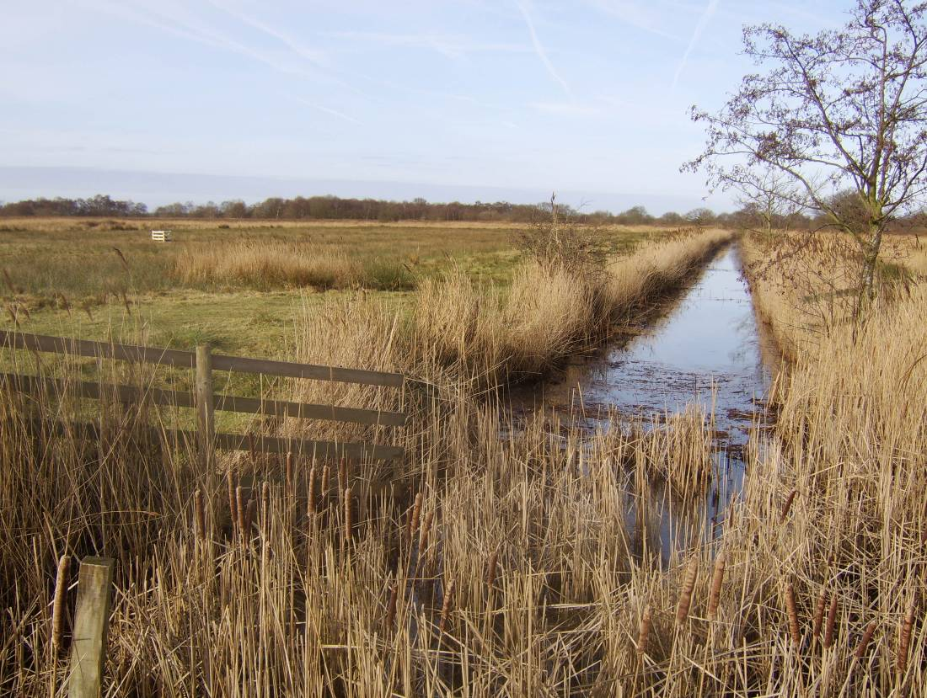

Holman, IP

October 2009

Department of Natural Resources
Cranfield University
Cranfield
Bedfordshire
MK43 0AL
Telephone: +44 (0) 1234 750111 Ext. 2764
Fax: +44 (0) 1234 752970

Table of contents

Table of contents i
1 Introduction 1
1.1 Objectives 1
2 Peat soils, drainage and wastage 1
2.1 Classification of soils containing peat horizons 1
2.1.1 Peat soil classification 1
2.1.2 Other soils which contain peat 1
2.2 Drainage and wastage 2
3. Available soil information on the peats of Fenland 3
3.1 Soil Maps 3
3.2 Inventory 4
4 Methodology and Results 4
4.1 Area of peat 4
4.2 Peat thickness 7
4.3 Carbon storage within the peat soils in Fenland 12
4.4 Carbon emissions from Fenland peats 12
4.4.1 Annual volume loss or wastage 12
4.4.2 Estimated carbon emissions from drained Fenland peat 14
5 Conclusions 14
6 Recommendations for further work 14
7 References 16

1 Introduction
Lowland peat sites can deliver a range of valuable ecosystem services including supporting biodiversity, carbon storage, food production and flood attenuation. However, many lowland peat soils are suitable for agricultural uses where effectively drained and so have been primarily managed to support food production at the expense of other ecosystem services. The RSPB commissioned this report to gain a better understanding of the impacts of current land management on peat reserves in the East Anglian Fens.

The Lowland Peat Survey of England and Wales (Burton and Hodgson, 1987) systematically recorded the lowland peats across the country and recognised 103,122 ha of peat. Of this 36,636 ha (35 %) were mapped in Eastern England, of which lowland peat soils covered 24,000 ha of the Fenlands at the time, “though they are decreasing in extent and becoming disjointed as they waste under arable use”. Arable or horticultural cropping eventually leads to the destruction of peat and soil quality commonly declines, eventually necessitating a further change in land use (Burton and Hodgson, 1987). Holme Fen in Cambridgeshire, home to the famous Holme Post, is a classic example of this.

1.1 Objectives
The objective of this project is to:

- Identify the likely area of remaining peat soils in Fenland and their depth.
- Estimate the carbon storage within the peat soils in Fenland.
- Assess the significance of the carbon emissions associated with peat losses in Fenland

2 Peat soils, drainage and wastage

2.1 Classification of soils containing peat horizons

2.1.1 Peat soil classification
The soil classification used in England and Wales (Avery 1980), Clayden and Hollis, 1984) is a hierarchical system with classes in four categories (major soil group, soil group, soil subgroup and soil series) defined by progressive division.

Ten Major Soil Groups are recognised, of which Major Soil Group 10 is Peat Soils. They are required to meet both of the following criteria:
- Either more than 40 cm of organic material within the upper 80 cm of the profile, or more than 30 cm of organic material resting directly on bedrock or skeletal material;
- No superficial non-humose mineral horizon with a colour value of 4 or more that extent below 30 cm depth.

As a simplification, this therefore indicates that for a soil to be mapped as a peat, the peat must be at least 40 cm thick and not be buried by more than 30 cm of mineral layers with low organic carbon.

2.1.2 Other soils which contain peat
Peat horizons can occur within a number of other Soil Subgroups and soil series within the hierarchical soil classification that do not qualify under Soil Major Group 10 (Peat Soils). These will either have (1) surface peat horizons which are less than 40 cm thick, often as a result of wastage of previously thicker peat deposits, or (2) peat layers which start at a depth of greater than 30 cm (but which may be of significant thickness).

2.2 Drainage and wastage
The use of peatlands for improved pasture, or for arable or horticultural production requires drainage. Drainage leads to subsidence of the ground surface and the eventual destruction of the fragile peat. There are several components to peat wastage, the general term used to account for the loss of peat:
- Shrinkage – the removal of large amounts of water from the peat produces rapid initial shrinkage, with rates of 18 cm/a in Holme Fen, Cambridgeshire, between 1850 and 1860 (Hutchinson, 1980);
- Compression – drainage also reduces the buoyancy effect of water which causes compression of peat under its own weight and increased bulk density. Passage of machinery increases the compaction;
- Oxidation – under the ensuing aerobic conditions, decomposition (biochemical oxidation) becomes the dominant processes, mainly affecting the peat above the watertable
- Other lesser components of wastage, including:
  - Wind erosion – where spring-sown crops offer a bare, loose soil surface to strong winds
  - Removal of soil on root crops
  - Accidental burning of dry peat

Wastage is greatest in thick peat deposits and where watertables are lowest. The rate of decomposition may be accelerated by liming, by mixing with mineral soil material and by an increased frequency of wetting and drying cycles (Burton and Hodgson, 1987). The most complete record of peat wastage is that from Holme Fen, as described by Hutchinson (1980). The record shows four stages of peat wastage over the history of the record from the 1850s until the 1970s, each associated with an ‘improvement’ in the drainage regime i.e. a lowering of the pumped water level. Within each stage, the rate of peat wastage exponentially decreases with time in each stage. Within the final Stage 4 (1962-1978) described by Hutchinson (1980) the peat surface lowered by around 1 cm/yr.

The original deep peatlands of the Fens are expected to have suffered more wastage than the 3.9 m measured at the Holme Post (Hutchinson, 1980), chiefly because they have been drained for longer and have been more continuously under intensive arable cultivation, particularly during the 20th Century. The alkalinity of fen peats will also have tended to produce higher wastage rates than in the acidic raised bog peats which form the upper part of the Holme Fen profile. The lowering of the surface levels in the “black Fens” was estimated by Fowler (1933) as up to 4.6 or 4.9 m (compared with about 3.3m at Holme Post at that time).

Other estimates of peat wastage are:
- average wastage value in the Fens of 0.6 cm/yr for the 200 years of wind pump drainage and about 2.5 cm/yr for the later more intensive drainage and cultivation period (Fowler et al. 1931)
- peat wastage of 1.8 cm/yr over the period 1934-1962 at Shippea Hill, Isle of Ely (Clark et al., 1935 and Clark and Godwin, 1962)
- mean annual wastage of 2.5cm/yr at Bourne South Fen, Lincolnshire (Miers, 1970)
- mean annual wastage between 1952-1962 of 0.7 cm/yr for shallow peat (less than 90cm depth) and 2.1 cm/yr for deeper peat, based on a systematic grid pattern of peat depth measurement at 131 points across the southern area of the Fens (Herbert, 1971).
- mean wastage rate of 1.37 (+0.78) cm/yr between 1941-1971 at 14 sites across the Fens (Richardson and Smith, 1978). When the data was sub-divided between 1941-55 and 1955-1971, wastage rates were higher at all but one site in the earlier period
- mean wastage rates for ‘thick’ and ‘thin’ peat of 1.27 cm/yr and 0.19 cm/yr, respectively are used for drained lowland wetlands including the East Anglian Fens by Milne et al. (2006). Although ‘thin peats’ have depths of up to 1 m, the low wastage rate used by Milne et al. (2006) for this group is likely to reflect the inclusion of non-peat ‘Skirtland’ soils.
- Brunning (2001) suggests that peat wastage in pasture fields in the Somerset Levels is occurring at rates of between 44 cm and 79 cm a century
- Studies in the Netherlands show land levels lowering by 1 cm yr⁻¹ under normal agricultural use (Acreman and Miller, 2007)

3. Available soil information on the peats of Fenland

3.1 Soil Maps
There are a number of soil maps produced by the Soil Survey of England and Wales that provide complete coverage of Fenland (Figure 1), albeit at different scales. Complete coverage is provided by the National Soil Map of England and Wales at 1:250,000 scale, but more detailed mapping is available for selected areas as scales ranging from 1:10,000 to 1:63,360 scales.

Figure 1 Distribution of detailed soil maps within Fenland

3.2 Inventory
The Lowland Peat Survey of England and Wales (Burton and Hodgson, 1987) surveyed the main lowland peat areas below 200 mOD. The inventory incorporated information from earlier Soil Survey reports augmented by purpose-made site descriptions and samples. During fieldwork, sites were investigated by hand-auger borings, generally at 500m intersections of the National Grid. Where possible the borings were made through the whole of the peat sequence into older deposits.

4 Methodology and Results
The methodology used within the current study is schematically shown in Figure 2.

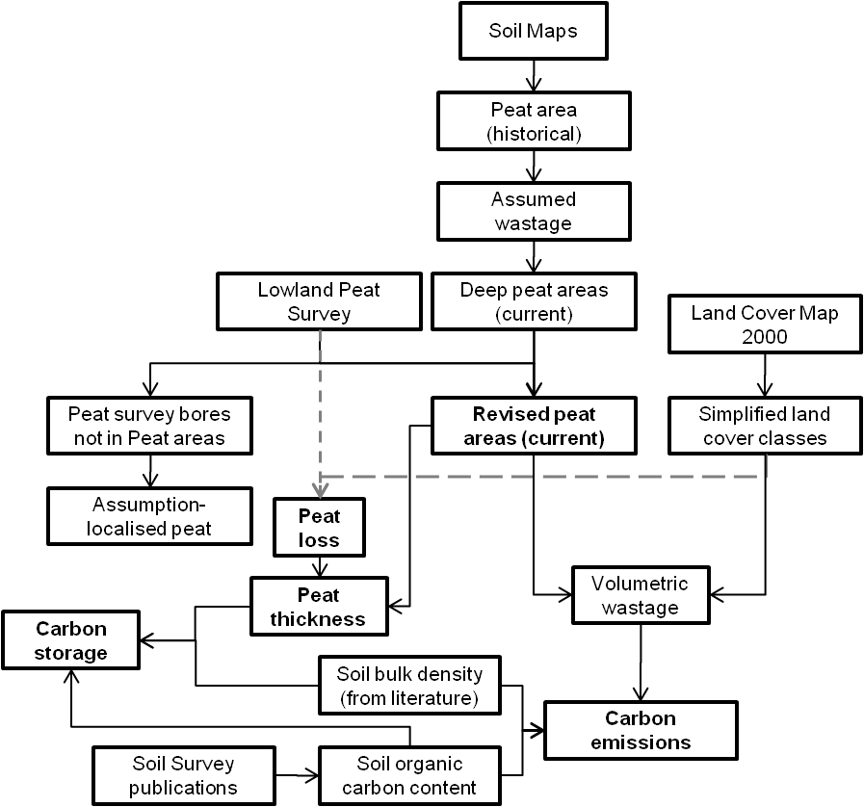

Figure 2 Overview of methodology to assess the extent and area of peat in Fenland

4.1 Area of peat
The legends and reports accompanying each soil map have been analysed to identify those soils either classified as Peat Soils (Major Group 10) or likely to contain peat layers within the profile. Such soils have been categorised, based on the information at the time of soil mapping, as:
- ‘Deep’ peat – peat soils which generally exceeded 100 cm in thickness at the time of mapping;
- ‘Thin’ peat - peat soils which were generally less that 100 cm in thickness;
- Localised peat – soil mapping units in which there is a mixture of peat and non-peat soils, the latter often having humose to peaty topsoils;
- Peat at depth – soils containing peat layers within the soil horizon covered by more than 30 cm of generally alluvial mineral material;
- Remnant peat- soils which were likely to have originally been peat soils but which have wasted to humose or mineral soils, termed skirtland. Very localised areas of thin peat may be present within these areas.

However, given the continuing peat wastage since the original soil surveying, which in some cases was more than forty years ago, the extent of current peat will be significantly less. From the review of peat wastage rates in Section 2, it appears reasonable that peat wastage rates since the soil surveys will be in the range of 0.7-2.1 cm/yr for those sites under intensive cultivation. Seale (1975b) stated that the “best estimate” of wastage suggests that in 35 years time (e.g. 2010) peat that was 90 cm thick will be skirtland. It has therefore been assumed that all of the original areas of Thin peat will have wasted to skirtland (peat remnant). Within the Deep Peat areas, it has been assumed that they will still currently be Deep Peat, with the exception of those areas surrounding Lowland Peat Survey observations with less than 1m of peat which will now be predominantly Thin Peat. Figure 3 shows the resultant map of peat extent. Apparent discontinuities reflect the boundaries of map sheets.

Based on Figure 3, it is estimated that there are four Drainage Board Groups in Fenland which contain areas of extensive peat soils. Combined, the South Level, Middle Level, Witham and Nene Drainage Boards contain an estimated 16,500 ha of surviving peat soils. Within these, there are 33 Internal Drainage Districts (IDD) which contain areas of extensive peat soils. Of these, 5 are estimated to each contain more than 1000ha of surviving peat soils- the Southery and District IDD, Witham 3rd District IDD, Holmewood and District IDB, Middle Fen and Mere IDD and Witham 1st District IDD, which together contain over 50% of the estimated surviving peat soils.

Figure 3 Estimated extent of current peat soils within Fenland, with location of Lowland Peat Survey observations of peat

4.2 Peat thickness
Within conventional soil survey, the thickness of peat deposits is not usually determined, as the reference section for classifying the proposal extends to no more than 1 m depth. Although there is peat depth information available within some of the detailed soil maps, the principal systematic dataset is the Lowland Peat Survey (Burton and Hodgson, 1987). Figure 4 shows the distribution of sampled sites and the measured thickness of peat.

Figure 4 Thickness of peat in the Fenland measured during the lowland peat survey (based on Burton and Hodgson, 1987)

The distribution of peat depths within these sites is shown in Figure 5, although the number of samples [n=946] in this dataset taken from Burton and Hodgson (1987) does not match the number of samples in Figure 5 above [n= 1018]. The mismatch partly relates to Fig 5 including soils with less than 40 cm of peat (which are hence not classified as peat soils), but may also not include those sites in Fig 5 with mineral surface layers.

The data in Figure 5 has been used to derive average peat thicknesses (Table 1) for the classes shown in Fig 4 above. Three important factors are apparent from Figure 6 and Table 1:

- The distribution of peat thickness in the arable sites is heavily skewed, with the highest frequency of sites having a peat thickness of less than 50 cm. Of the estimated 24,000 ha of peat soil in Fenland, Burton and Hodgson (1987) estimated that only 10,500 ha of peat soils had peat thicker than 1 m.
- The nature reserve and washland sites tend to have greater typical peat depths. Burton and Hodgson (1987) estimated that over 2300 ha of the 10,500 ha of peat soils with peat thicker than 1 m are located in nature reserves or under grass in flood relief washlands.

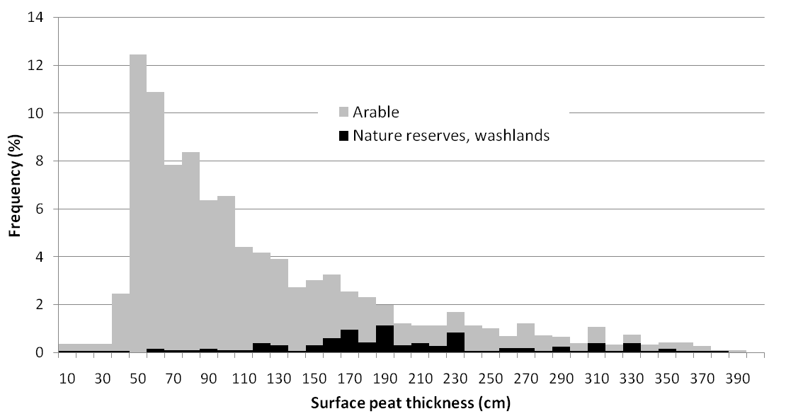

Figure 5 Frequency of surface peat thickness in Fenland (from Burton and Hodgson, 1987).

Table 1 Average peat thickness within peat thickness classes (using data from Burton and Hodgson, 1987)
 | Nature reserves, washlands |  | Arable
Peat thickness class (cm) | Frequency (%) | Average peat thickness (cm) | Frequency (%) | Average peat thickness (cm)
40-99 | 7 | 79 | 60 | 71
100-199 | 51 | 166 | 29 | 142
>200 | 42 | 287 | 11 | 278

Based on the literature reviewed in the earlier section, a range of wastage rates have been assumed (Table 2) which encapsulate increasing wastage rates with increasing need for drainage and with increasing peat thickness. Assuming that it is around 25 years since the fieldwork for the lowland peat survey, Figure 6 shows an estimate of the loss in peat thickness at each of the lowland peat survey observation bores, based upon original peat thickness class and current land cover (the latter derived from a simplification of the Land Cover Map 2000). Comparing the distribution of peat thickness in Figure 4 and the estimate proceeding wastage, it is apparent that a number of the thin peat soils with peat thicknesses of less than 70cm under arable land use will have changed into non-peat soils (i.e. the peat thickness after wastage is < 40cm).

Table 2 Assumed peat wastage rates (cm yr⁻¹)
 | Land cover
Peat thickness | Intensive arable | Intensive grassland | Semi-natural
Deep (> 1m) | 2.1 | 0.8 | 0.4
Thin (< 1 m) | 1.3 | 0.7 | 0.1

A current thickness of peat at each Lowland Peat observation point has been calculated from the average peat thickness for the appropriate peat thickness class (Table 1) and the estimated loss in peat thickness (Figure 6). Each observation point has then been assigned to a soil polygon (Figure 3) using a ‘’point in polygon’ procedure within a GIS, and an average peat depth per polygon calculated. Those polygons classified as ‘peat remnants’ and ‘localised peats’ have then been removed, as any observations have been assumed to not be relevant to the overall soil polygon. The remaining observations, including those classified as ‘Peat at depth’, have been used to provide an indicative map of average peat thickness (Figure 7).
Figure 6 Estimated reduction in peat thickness over the past 25 years, based upon original peat thickness class and current landcover

Figure 7 Indicative estimated average current peat thickness

4.3 Carbon storage within the peat soils in Fenland
The carbon storage within the peat soils has been estimated from:

Carbon mass (kg) = V x ρ x (OC/100)

Where V is the volume of peat, ρ is the bulk density and OC is the soil organic carbon content (%).

The peat volume has been estimated from the area and average thickness of each polygon in Fig. 7. Bulk density is not routinely measured within soil surveys so that the peat bulk density of 480 kg m⁻³ used by Milne et al. (2006) has been used. An average organic carbon content of 31% has been used, based on analysis of published analytical data for Fenland peat soil horizons in Hodge and Seale (1966), Seale (1975a, b), Robson (1985), Seale and Hodge (1976), Burton and Seale (1981).

Based on the above assumptions and simplifications, the estimate carbon storage within the peat soils of Fenland is estimated at approximately 41 Tg of carbon. It must be recognised that there is considerable uncertainty in this estimate, due primarily to the data paucity.

4.4 Carbon emissions from Fenland peats

The carbon emissions from peat can be estimated from:

Carbon mass loss (kg yr⁻¹) = ∆V x ρ x (OC/100)

Where ∆V is the volume loss or wastage (m³ yr⁻¹), ρ is the bulk density and OC is the soil organic carbon content (%)

4.4.1 Annual volume loss or wastage
For the areas of Deep Peat and Peat soils within the IDB boundaries, the estimated annual wastage has been calculated from the estimated areas under each of the broad land cover classes and the respective wastage rate. There are approximately 12,600 ha of Deep peat and 3900 ha of Thin Peat within the IDB boundaries depicted on Figure 4, which are estimated to be wasting by 2.5 x 10⁶ m³/yr, equivalent to an average wastage rate of around 1.5 cm/yr

There is great uncertainty in the extent of localised areas of predominantly thin peat soils, which are expected to occur in complex patterns with non-peat soils. As a result, these peat soils have not been included within the wastage calculations.

The estimated spatial distribution of annual peat wastage by Internal Drainage District is shown in Figure 8.
Figure 8 Estimated annual volume loss or wastage of peat soils in Fenland by Internal Drainage District

4.4.2 Estimated carbon emissions from drained Fenland peat
Based on the above values of wastage, bulk density and organic carbon content, the carbon emissions from Fenland peat wastage is estimated at approximately 3.8 x 10⁸ kg C/yr or 0.4 Tg C/yr. This is equivalent to 9 % of the annual loss of Organic Carbon from 0-15 cm depth of all soils across England and Wales (Bellamy et al., 2005) and about 0.3% of the UK’s annual industrial emissions of CO₂.

5 Conclusions
An initial appraisal has been carried out of the current extent and wastage of peat in the Fenland of East Anglia. Based upon an assessment of the available soil information, ranging from 1:10,000 – 1:250,000 scales collected from the 1960s to 1980s, and the likely effects of peat wastage over the intervening years, it is estimated that there are around 16,500 ha of surviving peat soils within the South Level, Middle Level, Witham and Nene Internal Drainage Board areas. Within these Boards, 5 Internal Drainage Districts (IDD) are estimated to each contain more than 1000ha of surviving peat soils- the Southery and District IDD, Witham 3rd District IDD, Holmewood and District IDB, Middle Fen and Mere IDD and Witham 1st District IDD, and together contain over 50% of the estimate surviving peat soils. Table 3 shows the results for each Internal Drainage Board District in which appreciable areas of peat soils are considered to remain.

The carbon emissions from peat wastage were estimated from the annual volume loss or wastage, bulk density and soil organic carbon content. Based upon a review of the available literature, it appears likely that Fenland peat soils are wasting at up to around 2.1 cm/yr, with greater wastage rates associated with greatest need for drainage and increasing peat thickness. For the surviving areas of deep peat (12,600 ha) and peat (3900 ha) soils within the IDB boundaries, the annual wastage was estimated at approximately 2.5 x 10⁶ m³/yr, equivalent to an average wastage rate of around 1.5 cm/yr. Due to the great uncertainty in the extent of localised areas of predominantly thin peat soils, these have not been included within the estimated wastage. Based on these values, the annual carbon emissions from the wastage of Fenland peats are estimated at approximately 3.8 x 10⁸ kg C/yr or 0.4 Tg C/yr. This is equivalent to around 9 % of the annual loss of Organic Carbon from 0-15 cm depth of all soils across England and Wales reported by Bellamy et al. (2005) and about 0.3% of the UK’s annual industrial emissions of CO₂.

6 Recommendations for further work
The work reported represents an initial appraisal of the extent and wastage of peat in the Fenland of East Anglia. The work has required a number of assumptions and simplifications to be made, and has highlighted important issues of data quality. A number of recommendations for further work are therefore made:
- The spatial soil data for the Fenland area is between 40 and 25 years old, whilst the peat inventory data was collected around 25 years ago. Given the continuing likely wastage of peat soils and the uncertainty in these rates, it is recommended that an update of the Lowland Peat Survey inventory is carried out to characterise the extent and depth of current peat soils in the area;
- Analysis of the unpublished peat survey auger bore records, which are held in non-electronic formats, was outside the scope of this current study. More detailed analysis of these should be carried out to collate the observed peat thickness data at each observation point, rather than the peat thickness class used in this current study.
- Significant areas of soils with peat starting below 40 cm were not surveyed within the Lowland Peat Survey. The carbon storage within, and emissions from, these peats should be assessed.
Table 3 Summary of results by Internal Drainage Board District
IDB District | Estimated peat area (ha) | IDB District area (ha) | Annual Wastage (m³/yr) | Annual Carbon loss
 |  |  |  | Annual loss (kg C/yr) | % of total C loss
Burnt Fen IDD | 170 | 6493 | 28554 | 4248778 | 1.12
Cawdle Fen IDD | 57 | 802 | 9056 | 1347525 | 0.36
Conington and Holme IDD | 293 | 1153 | 49169 | 7316279 | 1.93
East of Ouse, Polver and Nar IDD | 293 | 7666 | 43894 | 6531391 | 1.72
Haddenham Level DCA | 565 | 3866 | 103317 | 15373556 | 4.05
Holmewood and District IDB | 1558 | 2643 | 254212 | 37826773 | 9.97
Hundred Foot Washes IDD | 347 | 1550 | 26915 | 4004946 | 1.06
Lakenheath IDD | 453 | 1949 | 70591 | 10503982 | 2.77
Littleport and Downham IDD | 206 | 11935 | 34323 | 5107240 | 1.35
Manea and Welney DCA | 4 | 2825 | 419 | 62328 | 0.02
March East IDD | 35 | 2804 | 6669 | 992381 | 0.26
Middle Fen and Mere IDD | 1161 | 8248 | 201835 | 30033111 | 7.92
Mildenhall IDD | 406 | 3435 | 59888 | 8911301 | 2.35
Nene Washlands DCA | 743 | 1949 | 67726 | 10077632 | 2.66
North Level IDB | 196 | 32295 | 22021 | 3276765 | 0.86
Northwold IDD | 133 | 258 | 18395 | 2737129 | 0.72
Old West DD | 25 | 4701 | 5309 | 790040 | 0.21
Padnal and Waterden IDD | 411 | 1236 | 72468 | 10783218 | 2.84
Ramsey 4th IDD | 50 | 1534 | 9195 | 1368264 | 0.36
Ramsey, Upwood and Great Raveley IDD | 149 | 1315 | 28188 | 4194331 | 1.11
Sawtry IDD | 205 | 1660 | 17370 | 2584633 | 0.68
Southery and District IDD | 3627 | 9122 | 584247 | 86935971 | 22.92
Stoke Ferry IDD | 33 | 2078 | 6314 | 939517 | 0.25
Sutton and Mepal IDD | 240 | 4369 | 42943 | 6389873 | 1.68
Swaffham IDD | 821 | 5511 | 136631 | 20330676 | 5.36
The Curf and Wimblington Combined IDB | 3 | 2486 | 635 | 94489 | 0.02
Upper Witham IDD | 0.3 | 25001 | 59 | 8722 | 0.00
Warboys, Somersham and Pidley IDD | 65 | 4818 | 13434 | 1998910 | 0.53
Waterbeach Level IDD | 750 | 2738 | 121447 | 18071308 | 4.76
Whittlesey IDD | 477 | 8431 | 91029 | 13545073 | 3.57
Witham 1st District IDD | 1102 | 17249 | 143384 | 21335572 | 5.62
Witham 3rd District IDD | 1501 | 16237 | 196387 | 29222382 | 7.70
Woodwalton DCA | 494 | 690 | 83600 | 12439644 | 3.28
Estimated Total | ~16500 ha | 199046 ha | ~2.5x10⁶ m³/yr | ~3.8x10⁸ kg C/yr | -

7 References
Acreman MC, Miller F. (2007). Hydrological impact assessment of wetlands. In Proceedings of the ISGWAS Conference on Groundwater Sustainability, Spain, January 2006. p 225-255 http://aguas.igme.es/igme/isgwas/Ponencias%20ISGWAS/16-Acreman.pdf
Avery BW (1980). Soil classification for England and Wales: Higher categories. Soil Survey Technical Monograph No. 14, Harpenden
Bellamy, P.H. & Loveland, P.J. & Bradley, R.I. & Lark, M.R. & Kirk, G.J.D. (2005) Carbon losses from all soils across England and Wales 1978-2003. Nature, 437, 245-248.
Brunning, R. (2001). Archaeology and peat wastage on the Somerset Moors. Report to the Environment Agency, Somerset County Council, Taunton
Burton RGO and Seale RS (1981). Soils in Cambridgeshire I- Sheet TL18E/28W (Stilton). Soil Survey Record No 65. Soil Survey of England and Wales, Harpenden.
Burton RGO and Hodgson JM (1987). Lowland Peat in England and Wales. Soil Survey Special Survey No. 15. Soil Survey of England and Wales, Harpenden
Clark JGD, Godwin H, Godwin ME and Clifford MH (1935). Report on the recent observations at Peacock’s Farm, Shippea Hill, Cambridgeshire. Antiquaries J., 15, 284-319
Clark JGD and Godwin H (1962). The Neolithic in the Cambridgeshire Fens. Antiquity, 36, 10-23
Clayden B and Hollis JM (1984). Criteria for differentiating soil series. Soil Survey Technical Monograph No. 17, Harpenden.
Fowler G (1933). Shrinkage of the peat-covered Fenlands. Geographical Journal, 81, 149-150
FowlerG, Lethbridge TC and Sayee RU (1931). A skeleton of the early Bronze Age found in the Fens. Proc. Prehist. Soc. E. Ang. 6, 362-364
Herbert A (1971). Soil Survey of England and Wales. Personal communication to Richardson and Smith (1977).
Hodge CAH and Seale RS (1966). Soils of the District around Cambridge. Soil Survey Memoir No 8. Soil Survey of England and Wales, Harpenden.
Hutchinson, JN (1980). The record of peat wastage in the East Anglian Fenlands at Hole Post, 1848-1978 AD. J. Ecology 68, 229-249.
Miers RH (1970). Design of underdrainage based on field evidence in England and Wales. MSc thesis, Newcastle University
Milne, R.; Mobbs, D. C.; Thomson, A. M.; Matthews, R. W.; Broadmeadow, M. S. J.; Mackie, E.; Wilkinson, M.; Benham, S.; Harris, K.; Grace, J.; Quegan, S.; Coleman, K.; Powlson, D. S.; Whitmore, A. P.; Sozanska-Stanton, M.; Smith, P.; Levy, P. E.; Ostle, N.; Murray, T. D.; Van Oijen, M.; Brown, T. (2006). UK emissions by sources and removals by sinks due to land use, land use change and forestry activities. Report, April 2006. Centre for Ecology and Hydrology, 278pp. (CEH: Project Report Number C02275).
Richardson SJ and Smith J (1977). Peat wastage in the East Anglian Fens. J. of Soil Science, 28, 485-489.
Robson JD (1985). Soils in Lincolnshire IV- Sheet TF45 (Friskney). Soil Survey Record No 88. Soil Survey of England and Wales, Harpenden.
Robson JD (1990). Soils of the Boston and Spalding District. Memoir of the Soil Survey of Great Britain. Soil Survey and Land Research Centre, Silsoe.
Seale RS and Hodge CAH (1976). Soils of the Cambridge and Ely District. Soil Survey Special Survey No. 10. Soil Survey of England and Wales, Harpenden
Seale RS (1975a). Soils of the Chatteris District of Cambridgeshire. Soil Survey Special Survey No. 9. Soil Survey of England and Wales, Harpenden
Seale RS (1975b). Soils of the Ely District. Soil Survey Memoir No 21. Soil Survey of England and Wales, Harpenden.

